Borden County
Surplus Office Equipment
Posting Dates: April 15, 2026 – May 5, 2026
Send amount proposed for purchase by May 11, 2026, with name, phone number and amounts you are submitting for purchase to cpalmer@co.borden.tx.us. There are no minimums.
Call 903-316-8843 for more information

Dell Computer Monitor
Epson Scanner
Casio Adding Machine
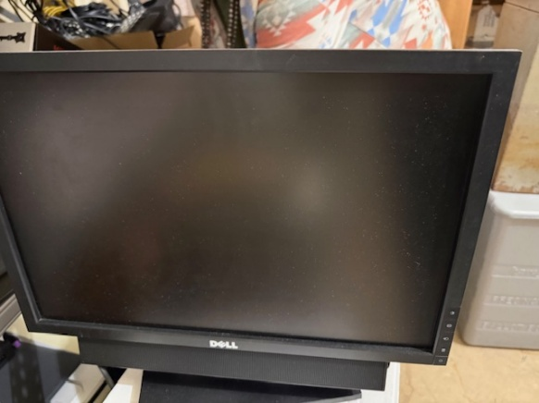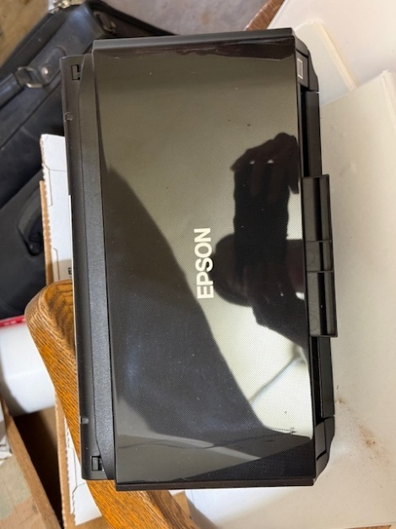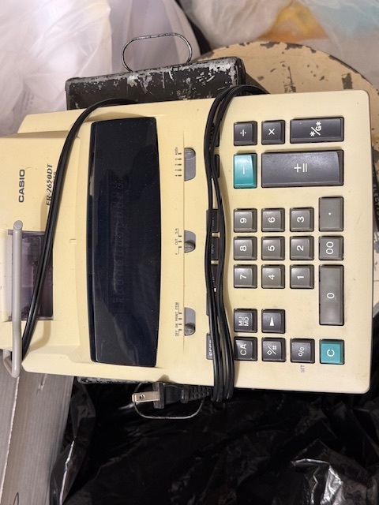

Computer Stand
Various Items:
- Computer Stand
- Keyboard
- Printer
- Binder
- Computer laptop
- Pencil
- Sharpener
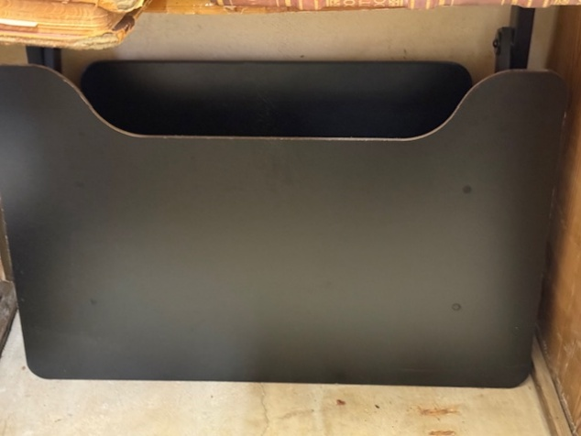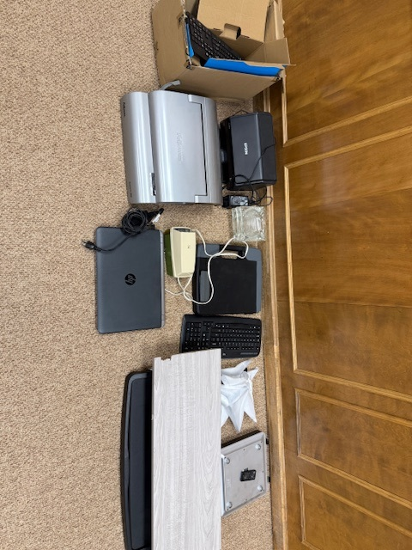

Texas Report Books
HP Printer
CD Burner
Various Phone Items

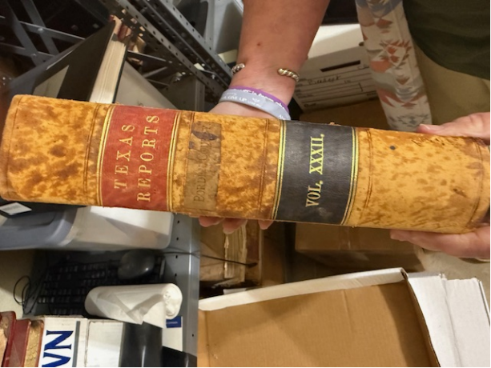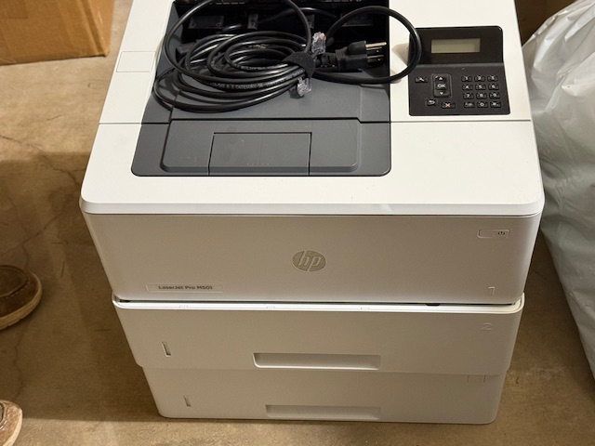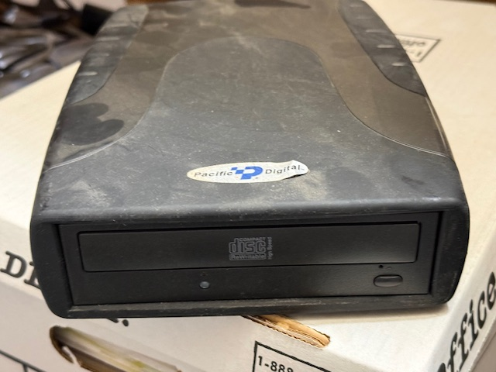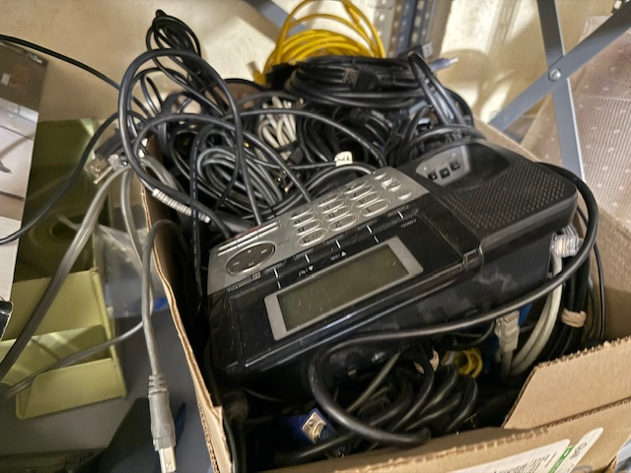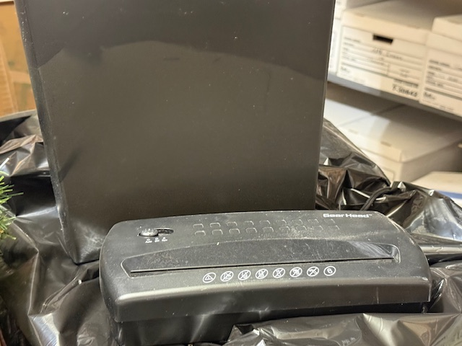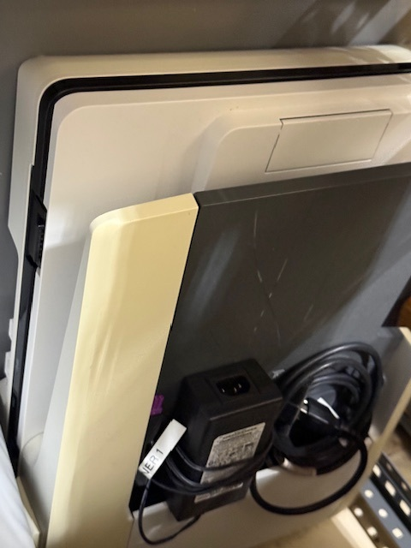

Shredder
Older Scanner

